Jan 2020

SUTTON UPON DERWENT
PARISH COUNCIL

Community Emergency Plan
including Severe Weather

CONTEnts

Contents 1
Section 1 2
Emergency Management Team 2
Emergency Community Coordinators 2
Incident Room & Emergency Shelters 2
Emergency Box 3
Emergency Information Points 3
Section 2 3
Before an Emergency (general advice) 3
When an Emergency is Expected (general advice) 5
During an Emergency (general advice) 6
Activation of the Community Emergency Plan 7
Emergency Management Team Checklist 7
Flooding specific actions 8
Flood Specific Response Measures 10
Sketch Map Showing Locations at Risk of Flooding and the Flow Route 11
Snow & Frost Specific Information 12
Pre-Identified Snow Clearance Areas 12
Roads Treated by East Riding of Yorkshire Council 12
Resources for Snow Clearance 13
Salt Bins 13
Contractor/Farmer/Land Owner Information 14
Encouraging Others to Clear Snow & Ice 14
Snow Clearance Map 14
Record of Snow Clearance Work 16
Section 3 16
Community Resources Available for use during an emergency 16
Community Organisations or People with a skill, who could help during an emergency 17
Section 4 17
Vulnerable members of the Community who may need help during an emergency 17
Section 5 18
Emergency Contact Directory 18
Section 6 22
Plan Publication 22
Section 7 22
Plan Maintenance Roles and Responsibilities 22

SECTION 1.

Emergency Management Team

In the event of the plan being triggered the following members of the Parish Council have agreed to form part of the Emergency Management Team (EMT) who will help to reduce the effects on the community:
Andrew Hardcastle, Tara Cox, Mark McCaffrey, Mike Piercy and The Clerk
The role of the Emergency Management Team (EMT) is to co-ordinate the activities of your Council during an emergency by assessing the situation, including weather and ground conditions, mobilising the appropriate local resources to support the community and maintaining links with the emergency services, the local authority and other responding organisations.

The contact numbers here will be held by East Riding of Yorkshire Council and the Emergency Services and will be the numbers used to contact your Parish Council during an emergency. During a wide area emergency e-mail may be the only feasible form of communication.

Emergency Community Coordinators

These are members of the community willing to help during an emergency, doing tasks such as door knocking, snow clearance or shopping for vulnerable people for example. A list of co-ordinators is provided in Section 5.

Incident Room & Emergency Shelters

If an emergency team is brought together, it has been agreed that they will meet in one of the following locations:
Location | Keyholders | Contact Information | Availability
The Village Hall  Main Street  Sutton upon Derwent  YO41 4BN | Redacted for GDPR | Redacted for GDPR | 24/7  24/7  24/7
St Vincent’s Arms  Main Street  Sutton on Derwent  YO41 4BN | Redacted for GDPR | Redacted for GDPR | 24/7

Details of the emergency shelters will be shared with the emergency services in case they need to identify a safe location to evacuate residents to.

Emergency Box

Location redacted for security reasons

The emergency box is to be checked on a biannual basis and recorded within Parish Council meeting minutes.

Emergency Information Points

The following locations will be used to pass information to the community during an emergency.

The parish council have a website and access to social networking sites which will be used to keep everyone informed of the latest situation.

Location | Responsible for updates | Contact Information
Village Web site  www.suttonuponderwent.org.uk | Andrew Hardcastle | Redacted for GDPR
The Village Hall Notice Boards, Main Street, YO41 4BN  Wynam Lane Notice Board  YO41 4BR  Holly Tree Farm Notice Board Main St. YO41 4BT | Parish Council Clerk | theclerk@suttonuponderwent.org.uk

One member of the Emergency Management Team is responsible for making sure all the Emergency Information Points have the same information to avoid confusion. This Person is the Clerk.

SECTION 2 - Before an Emergency (general advice)

Help the Community Prepare

Every household in the East Riding of Yorkshire was sent a “Let’s Get Ready for Winter” booklet from East Riding of Yorkshire Council, also available “Make Time for Winter”. You can help your community be prepared for an emergency by encouraging all residents to follow the advice contained in those documents. The Parish Council therefore:

- Encourages all members of the community to make sure they are adequately insured and have reviewed their insurance
- Encourages all members of the community to be aware of and signed up to the Environment Agency Flood Warning Service. All members of the community are encouraged to view the National Flood Forum for more information on flood defence products, to local surveyors and architects for advice on their effectiveness.
- Encourages all members of the community to prepare a Go Bag including:
- Key documents (such as passport, driving licence, your personal emergency contact list and insurance details).
- First aid kit including any medication.
- Wet wipes and/or antibacterial hand gel.
- Battery operated radio with spare batteries or wind up radio.
- Notebook and pencil/pen.
- Mobile phone/charger.
- Glasses/contact lenses.
- Toiletries (including nappies/sanitary supplies).
- Any special items for babies, children, elderly and disabled people.
- Spare set of keys (home/car/office).
- Bottled water/energy bars.
- Coins/cash (small denominations) and credit/debit cards.
- Change of clothes and blankets and sensible footwear (if necessary, waterproofs).
- A torch and batteries or a wind up torch.

- Encourages all members of the community to complete a household emergency plan
- Encourages all members of the community to make a “Community Friend” – this is someone, or some people, that can be called during an emergency to provide practical support – such as helping move furniture, look after pets, share house keys to look after each other’s properties and maybe know which valuable and sentimental items should be moved upstairs, check on you if you are poorly and go to the shops and chemists on your behalf.
- Encourages all members of the community to know how to respond. In an emergency, people should go inside go in, stay in and tune in to their local radio station for further instructions and updates (see Section 5) – unless there is a fire, or any other threat to staying in the property, or unless they have been advised otherwise by the Emergency Services.
- Promote the community to be ready for an emergency – households to consider:
- Do you have a household emergency plan?
- Have you discussed your plan with family and friends?
- Do you know the emergency plan for your children’s school/nursery/college?
- Do you know the emergency plan for your place of work?
- Have you completed a personal emergency contact list?
- Have you prepared a check list for your ‘go bag’, or packed it ready to go?
- Do you have ICE contact(s) in your phone, wallet or purse?
- Do you have a contact person – someone unlikely to be affected by the same emergency - who can keep family and friends informed?
- Do you have a wind up or battery-operated portable FM/AM radio?
- Do you have alternative, agreed meeting points?
- Do you have working smoke alarms in your home?
- Do you have adequate contents and buildings insurance?
- Do you have copies of your most important documents stored somewhere other than at home?
- Do you have a written list of your valuables, plus photographs or DVD/video?
- Have you undertaken a basic first aid course?
- Have you checked if your property is in a flood risk area?
- Have you thought about arrangements for pets if you need to leave your home?
- Have you identified possible exit routes from every room in your home?

Copies of the leaflets are also available from ERYC, tel. 01482 393095.The Environment Agency has flooding specific information for communities in flood risk areas. Call 0345 988 1188 for more information.

Make sure that you are prepared

- Make sure that you have your own household plan and go bag up to date and ready
- Buy a wind up torch and wind up radio.
- Let people know you are willing to act as a co-ordinator during an emergency
- Find out whether you Town or Parish Council have their own Community Emergency Plan that you can link into
You might be able to make contact with another community co-ordinator from another Neighbourhood Watch group; someone who is unlikely to be affected by the same emergency and who might be able to act as a runner to pass you radio alerts if you lose power.

When an Emergency is Expected (general advice)

If you can, let people in your community know what’s happening and advise people to be aware of the situation.

Use the following advice in unusual weather conditions:

Heavy Winds
- Secure loose objects such as ladders and garden furniture
- Close and securely fasten doors and windows, including garages
- Park vehicles in a garage or in a place clear of buildings, trees and fences
- Stay indoors if possible
- If you need to go outside, do not walk or shelter close to buildings or trees
- Don’t carry out repairs whilst the storm is in progress
- Do not drive unless your journey is essential and avoid exposed routes
- Do not touch electric/telephone cables which may have be blown down

Heat Wave
- Try and plan your day to stay out of the heat, keep rooms shaded and, where possible use a fan
- If you must go out, stay in the shade, wear a hat and loose fitting clothing
- Drink plenty of fluids
- Don’t leave animals unattended in cars in warm weather
- Seek medical help if you suffer from heat exhaustion or heat stroke. Remain somewhere cool, sponge yourself with cold water and drink plenty of fluids

Snow and Ice
- Carry an emergency car kit – mobile phone, car charger, first aid kit, warm waterproof clothes, blanket, food, water, torch (with spare batteries)
- Inform a friend or family member of your intended travel arrangements and expected arrival time
- Wear a hat
- Watch out for signs of hypothermia – uncontrollable shivering, slow or slurred speech, drowsiness and memory lapse
- Don’t drive unless you absolutely need to
Flooding
- Listen to your local radio and TV weather forecasts for advice from the emergency services
- Move your car to higher ground
- Empty furniture drawers and cupboards. Place the contents and any furniture you can upstairs
- Fasten plastic bags round the legs of wooden furniture to help minimise absorption of water
- Turn off mains gas and electricity
- Put plugs in sinks and weight them down to prevent backflow from the drains. Weigh down the loo seat too.
- Bring caged outdoor pets inside, move all pets with food, water, bedding and litter trays upstairs
- Make sure any valuable or sentimental items and important documents are safe
- Put any flood protection in place

REMEMBER flood water will probably contain sewage, which can cause disease. Always wash your hands/arms/legs after coming into contact with floodwater with hot water and soap. Keep contaminated footwear and clothing away from children

DO NOT allow children to play in floodwater, as well as the risk of disease manhole covers may have dislodged under the pressure of floodwater creating a drowning risk. If you need to walk through floodwater consider using a pole (brush handle) to test the ground in front of you

Encourage members of the community to check on their neighbours, especially if they are elderly or live on their own.

During an Emergency (general advice)

- IN AN EMERGENCY DIAL 999 IF NECESSARY
- Follow advice from the Emergency Services and responding organisations, make sure that your own family is safe, and that your house is secure
- Tune into the local radio station and listen for public advice messages

If you are able:

- Pass on any public advice messages to your community
- Make contact with your fellow coordinators
- Try to assess the impact of the emergency on your community and assess whether there is any support that you, or other community volunteers can provide, such as:

  - Helping people move valuable and sentimental items upstairs
  - Helping deploy any flood protection products they might have
  - Providing some immediate shelter if people have had to leave their homes
  - Looking after pets
  - Providing lifts to family and friends
  - Doing basic household tasks such as shopping

- Consider asking for additional members of the community (volunteers) to help with the response
- Co-ordinate offers of support where you can
- Pay particular attention to people that might be made vulnerable during an emergency
- Liaise with the Parish Council and the Community Emergency Plan
- If people are advised to evacuate their homes, or are advised to evacuate, try and remind people of the steps they should take:
  - Grab ‘Go bag’ and check contents.
  - Turn off electricity, gas and water supplies and unplug appliances
  - Take their mobile phone and charger.
  - Take some spare clothes.
  - Take prescribed medication with them.
  - Take cash and credit cards.
  - Lock all doors and windows.

If they leave by car, take bottled water, a duvet or blankets and tune into the local radio for emergency advice and instructions.

Activation of the Community Emergency Plan

There are a number of ways that you might be notified of an emergency. East Riding of Yorkshire Council has arrangements in place to contact you if there is an emergency in your area. This may be by e-mail if it is a major wide area emergency. The Emergency Services might contact you directly or one of your residents. There is no specific definition of an emergency in this document – your Council may want to use some of these arrangements in response to smaller incidents which wouldn’t usually be classed as an emergency.

How the Plan will be Activated
This plan will be activated when two or more of the Emergency Management Team decides that the plan should be triggered, and begins to follow the initial actions checklist.

Emergency Management Team Checklist

initial actions
- IN AN EMERGENCY DIAL 999

- Tune into BBC Radio Humberside (95.9 FM & DAB), BBC Radio York (95.5 FM & DAB) or Minster FM (104.7 FM) and listen for updates on the emergency. Follow any emergency services advice issued.

- If the situation does not require an immediate response, request the Parish / Town Clerk to convene an urgent meeting of the Parish Council.

- Gather as much information about the situation as possible and decide which local resources should be mobilised to support the community

- Consider whether you can work effectively from your current location, or whether you need to move to an alternate location. Arrange for the Incident Room to be opened as appropriate.

- The emergency team meet at the nominated location (see section 5) and instigate the call cascade as necessary.

- Make contact with the Emergency Services / East Riding of Yorkshire Council if they are involved in the incident.

- Arrange for contact to be made with the vulnerable members of the community identified in Section 4 as appropriate and arrange for advice / assistance to be offered. You might want to give this task to one person within the emergency team to co-ordinate.

- Arrange for the community resources / organisations to be made available as necessary. You might want to give this task to one person within the emergency team to co-ordinate.

- Consider asking for additional members of the community (volunteers) to help with the response, you may have pre-identified community coordinators already. You might want to give this task to one person within the emergency team to co-ordinate. The type of support that would be welcomed changes from emergency to emergency but might include:
    - Helping people move valuable and sentimental items upstairs
    - Helping deploy any flood protection products they might have
    - Providing some immediate shelter if people have had to leave their homes
    - Looking after pets
    - Providing lifts to family and friends
    - Doing basic household tasks such as shopping

- Check your designated emergency e-mail system regularly.

- Tell your community that your emergency team is functioning and if appropriate maintain a presence in the area(s) affected

- Establish contact with neighbouring Parish Councils and ask for / offer support if appropriate

- Ensure that any members of your community engaged in the response are not putting themselves at risk. Make sure they are acting lawfully (e.g. not speeding), carefully and are not carrying out tasks and activities that they are not qualified to do.

Flooding specific actions

additional actions (flooding)
- If you are in an area that receives flood warnings, dial Floodline on 0345 988 1188

- Refer to the “Flood Specific Response Measures” table. Implement any agreed actions as appropriate. Mobilise the pre-identified resources and make offer of support to those that may be vulnerable.

- Where ever possible, advise residents to:
  - Put any flood protection products they have into place
  - Move cars to higher ground
  - Make sure any valuable or sentimental items and important documents are safe
  - Empty furniture drawers and cupboards. Place the contents and any furniture you can upstairs. Fasten plastic bags round the legs of wooden furniture to help minimise absorption of water
  - Be prepared to turn off mains gas and electricity
  - Be prepared to evacuate if necessary:
    - Grab ‘Go bag’ and check contents.
    - Turn off electricity, gas and water supplies and unplug appliances
    - Take their mobile phone and charger.
    - Take some spare clothes.
    - Take prescribed medication with them.
    - Take cash and credit cards.
    - Lock all doors and windows.
    - If they leave by car, take bottled water, a duvet or blankets and tune into the local radio for emergency advice and instructions.

  - Put plugs in sinks and weight them down to prevent backflow from the drains. Weigh down the loo seat too.
  - Bring caged outdoor pets inside, move all pets with food, water, bedding and litter trays upstairs
  - Always wash their hands/arms/legs after coming into contact with floodwater with hot water and soap.
  - Keep contaminated footwear and clothing away from children
  - Never allow children to play in floodwater, as well as the risk of disease manhole covers may have dislodged under the pressure of floodwater creating a drowning risk.

- Try and provide support to residents in carrying out these actions.

Flood Specific Response Measures

Known Location at Risk | Action required before a flood | Action required during a flood | Equipment and People Required | Time Required | Any known areas of Vulnerable People affected
Area at junction of Wynam Lane and Carlton Road to junction of Wynam Lane and Main Street YO41 4BT | Keep culvert clear of debris  Make sure road gullies are clear of blockage | Inform emergency services  Use pumps to help with flow  Advise residents in area to be prepared for flooding | pump, Tractors, Telescopic loaders  gully suckers  EMT and pump  2 volunteers to door knock | 2 hours to set up  2 hours to complete door knock
B1228 Between Church Corner and River Bridge | Make sure road gullies are clear of blockage | Arrange Road Closure | ERYC / Police | 4 hours to set up
Dalton House, Main Street, YO41 4BT | Maintain contact with residents regarding any concerns of off field drainage and risk of flooding. | Inform emergency services  Use pumps to help with flow  Advise residents in area to be prepared for flooding | gully suckers  EMT and pump | 2 hours to set up

Sketch Map Showing Locations at Risk of Flooding
Locations at risk of flooding are shown RED:-

B1228 Main Street, through centre of village and junction of Wynam Lane and B1228 in centre of village

B1228 between Church Corner and River Bridge

Dalton House, Main Street, YO41 4BT
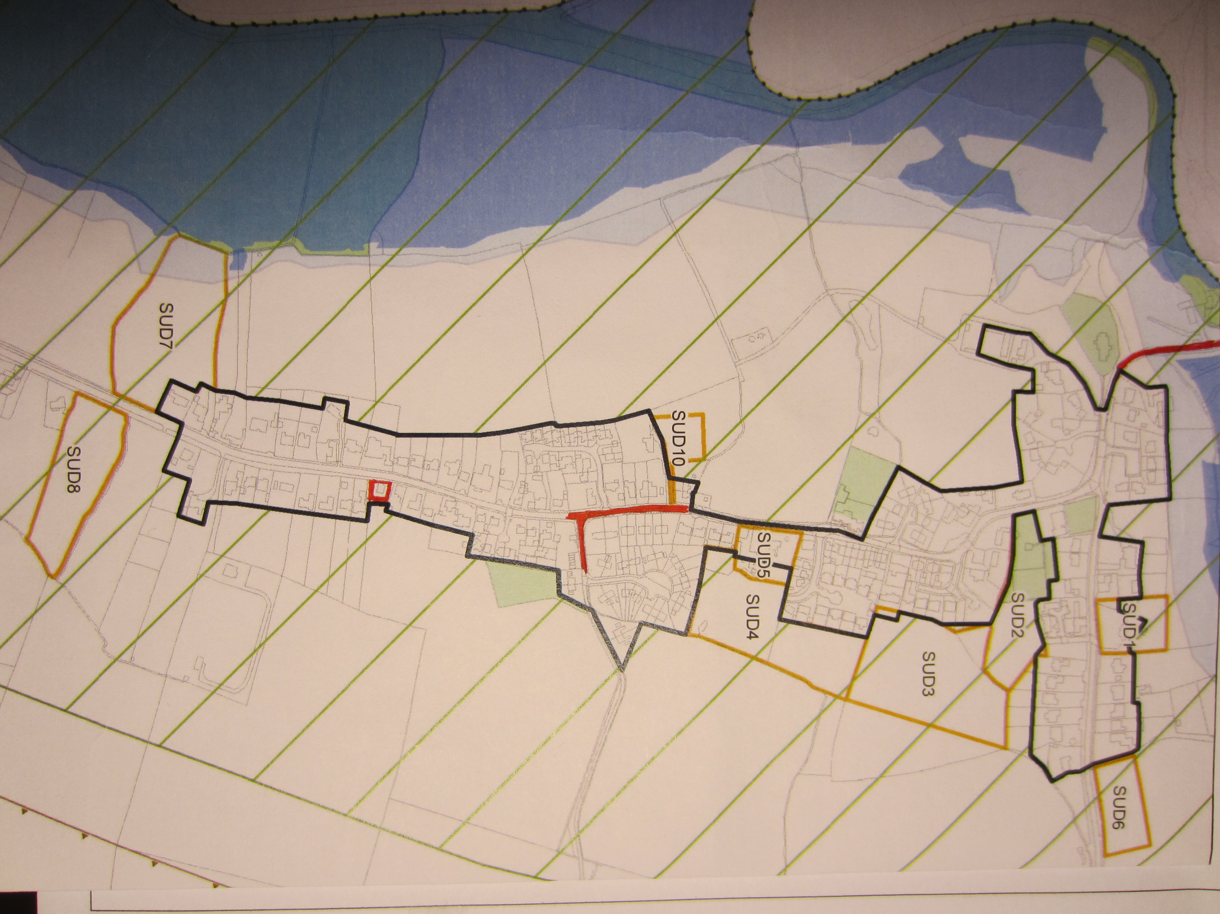

Snow and Frost Specific Information

- PRE-IDENTIFIED SNOW CLEARANCE AREAS (Parish Council)

The Parish Council has identified appropriate areas for snow clearance. Under extreme conditions, priority will be given to clearing the primary routes.

Primary
- Highway footpaths along the Main Street, B1228 through the centre of the village
- Pavements along Wynam Lane
- Pavements close to the school, village hall and Sutton Bridge
- Highway footpaths bordering C18

Secondary
- All other highway footpaths along the side roads within the village limits
- A set of the route cards are held by Parish Clerk

b) ROADS TREATED BY EAST RIDING OF YORKSHIRE COUNCIL

The following roads are on the East Riding of Yorkshire Council Precautionary Network:
- Main Street B1228
- Sandhill Lane C18

The following roads are on the East Riding of Yorkshire Council Secondary Network

- Side roads

c) RESOURCES FOR SNOW CLEARANCE

The Town / Parish Council have identified the following resources for use during snow clearance activities:
Grit Salt and pavement Spreader | Redacted for GDPR
Road gritter & Snow plough | Redacted for GDPR
Pavement snow sweeper | Redacted for GDPR

- Salt Bins

There are salt bins at the following locations:
Parish Council Owned Salt Bins
- At the junction of Main Street and Wynam Lane B1228
- At the corner on Main Street close to Gravel Pit Farm B1228
- Close to the primary school B1228

East Riding of Yorkshire Council Owned Salt Bins
- On B1228 opposite tennis courts

d) CONTRACTOR / FARMER / LAND OWNER INFORMATION

The Parish Council has an agreement with the following Contractor to clear the areas identified in Section a) above when requested by the Community Emergency Team.
Highway Footpaths & Pavements | Redacted for GDPR

Checks have been made to ensure that contractors have the appropriate license, training and insurance to carry out these activities. Details of the agreement and the checks carried out are held at Parish Council meetings.

Encouraging others to clear snow and ice
Every member of the community can play an important part in clearing snow and ice. The Parish Council keep a limited number of copies of the East Riding of Yorkshire Council information leaflet “Make Time for Winter” that encourage people to clear around their own property. The leaflet is also available from ERYC, tel. 01482 393095.

e) SNOW CLEARANCE MAP - Parish Council

During adverse winter weather, every effort will be made to clear the red coloured areas shown below, depending on the availability of resources, when snow in excess of 25mm has fallen.

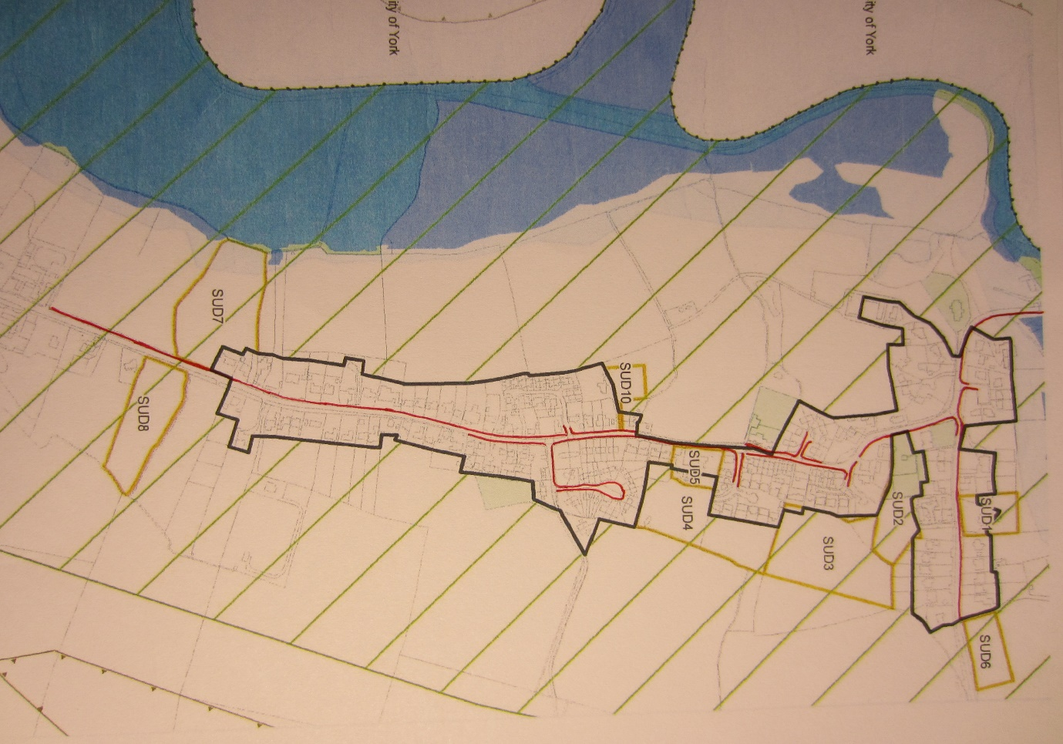

f) Record of Snow Clearance Work undertaken by Parish Council

The table below is an example of details required.
Date / Time | Work / Areas done | By Whom | Comments

SECTION 3 - Community Resources Available for use during an emergency

These pages identify the resources that exist in the community that could be used during an emergency.

Resources Available | Contact Details
Access to the Village Hall to shelter people if necessary | Redacted for GDPR
4 Wheel Drive & Tractor | Redacted for GDPR
Tractor | Redacted for GDPR
Drain Jetters / Gully Suckers / Snow Plough / Gritter | Redacted for GDPR
Tractor / Telescopic Loader | Redacted for GDPR
Snow Clearer | Redacted for GDPR
Grit Salt & Pavement Spreader | Redacted for GDPR

Community Organisations or People with a special skill, who could help during an emergency

Organisation / Persons Name & Contact Details | Resources Available
Rev. Ian Kitchen (Rector) | C of E Church

SECTION 4 - Vulnerable members of the Community who may need particular help during an emergency

Name, Address and Contact Information | Name, Address and Contact Information
Check with Emergency Coordinators at time of emergency

Rather than identifying specific vulnerable people, we would consider:
- Promoting the buddy system, where people are encouraged to check on their own next door neighbours.
- Pre-identifying particular areas where potential vulnerable groups are known to live and door knocking at the time of an emergency.
- Having a high profile presence (e.g. tabards) in the street to encourage vulnerable people to make themselves known during an emergency.

SECTION 5 - Emergency Contact Directory

Emergency Management Team

Name | Contact Information | Home address | E-mail address | Availability
Andrew Hardcastle  Parish Councillor | Redacted for GDPR
Yvonne Egglestone  Clerk to PC | Home - 01904 608453 | Windrush  Main Street  YO41 4BT | theclerk@suttonuponderwent.org.uk | 24/7
Mark McCaffrey  Parish Councillor | Redacted for GDPR
Tara Cox  Parish Councillor | Redacted for GDPR
Mike Piercy  Parish Councillor | Redacted for GDPR

Emergency Community Coordinators

Name | Contact Information | Home address | E-mail address | Availability | Area they willing to co-ordinate
John Newlove  Village Hall  Chairman | Redacted for GDPR
Peter Kirby | Redacted for GDPR
William Ward  Farmer | Redacted for GDPR

Parish Councillors not on the Emergency Management Team

Name | Contact Information | Home address | E-mail address
Maria Lovatt  Parish Councillor | Redacted for GDPR
Eric Smith  Parish Councillor | Redacted for GDPR
Mike Floyd  Parish Councillor | Redacted for GDPR

East Riding of Yorkshire Council Elected Members not on the Emergency Team / Parish Council

Name | Contact Information | Home address | E-mail address
Cllr Kay West | Redacted for GDPR

Details of Neighbouring Town and Parish Councils

Name | Town/Parish | Contact Information | E-mail address
The Clerk  David Headlam | Elvington Parish Council | Home – 01904 608721 | parishclerk@elvington.net
The Clerk  Lynn Hill | Newton on Derwent  Parish Council | Home – 01904 607036 | clerk@newtonuponderwent.info
The Clerk  Jane Stewart | Melbourne Parish  Council | Home – 01759 318674 | melbourneclerk@aol.com

External Contact Details:

- Fire, Police, Ambulance and Coastguard - 999
- Police Non-Emergency Number - 101
- NHS Choices – 111
- East Riding of Yorkshire Council (general enquiries) – 01482 393939
- ERYC Parish/Town Council Emergency Hotline – 01482 393536
- Environment Agency Floodline – 0345 988 1188
- Gas Emergency Service and Gas Escapes - 0800 111 999
- Electricity Emergency Service and Supply Failures – 0845 733 1331
- Yorkshire Water - 0845 124 24 24
- Maritime and Coastguard Agency – 01262 672317

Radio Humberside – Tune in to DAB or 95.9FM
Radio York – Tune into DAB or 95.5FM
Minster fm Tune into 104.7FM
www.bbc.co.uk/humber
www.metoffice.gov.uk
Contact Tree

Person who finds out about the incident

Nick Hobson
Chris Hobson
Charles Smallwood
Ricky Goode
Andrew Hardcastle
Mike Piercy
William Ward
Peter Kirby
The Rector
Parish Council
Elvington P.C. Clerk
Newton P.C. Clerk
Melbourne P.C. Clerk
Mark McCaffrey
Tara Cox
The Parish Clerk
St Vincent’s Arms
Sutton School

Pamela Street
John Newlove
Yvonne Eggleston

SECTION 6 - Plan Publication

Plan Publication
Electronic copies of this plan have been e-mailed to:

- heps@eastriding.gov.uk The ERY Council will write it into their emergency management arrangements and share it with the emergency services so they can do likewise.

The original electronic version of this plan is kept by The Clerk

Backup electronic versions of this plan are kept by the Emergency Management Team

Hard copies of this plan are kept at:
- In the Emergency Chest
- In the Parish Council Filing Cabinet, at the Village Hall

A web version of the plan with the confidential information removed has been posted on www.suttonuponderwent.org.uk public information.

Data Protection
This plan will contain personal information once complete. Parish Councils should be mindful of data protection legislation when completing and storing this plan.

SECTION 7 – Maintenance of Document - Roles and Responsibilities

- The plan should be reviewed annually. During the review every section of the plan should be checked for accuracy (telephone numbers, resource lists etc.). The Parish Clerk will have responsibility for reviewing the emergency plan and should report back the Parish Council meeting to confirm that a review has taken place.

- Any updates to the plan, or lessons that have been learned from exercises, should be approved by The Parish Council before the plan is changed.

- The Parish Clerk is responsible for providing an updated version of the plan to all those listed in Section 6.

The Parish Clerk should make sure that all the people who are involved in the plan aware of their role, and know that that they might be contacted during an emergency.

- The Parish Clerk is responsible for making sure the plan complies with Data Protection, and all other appropriate legislation.

